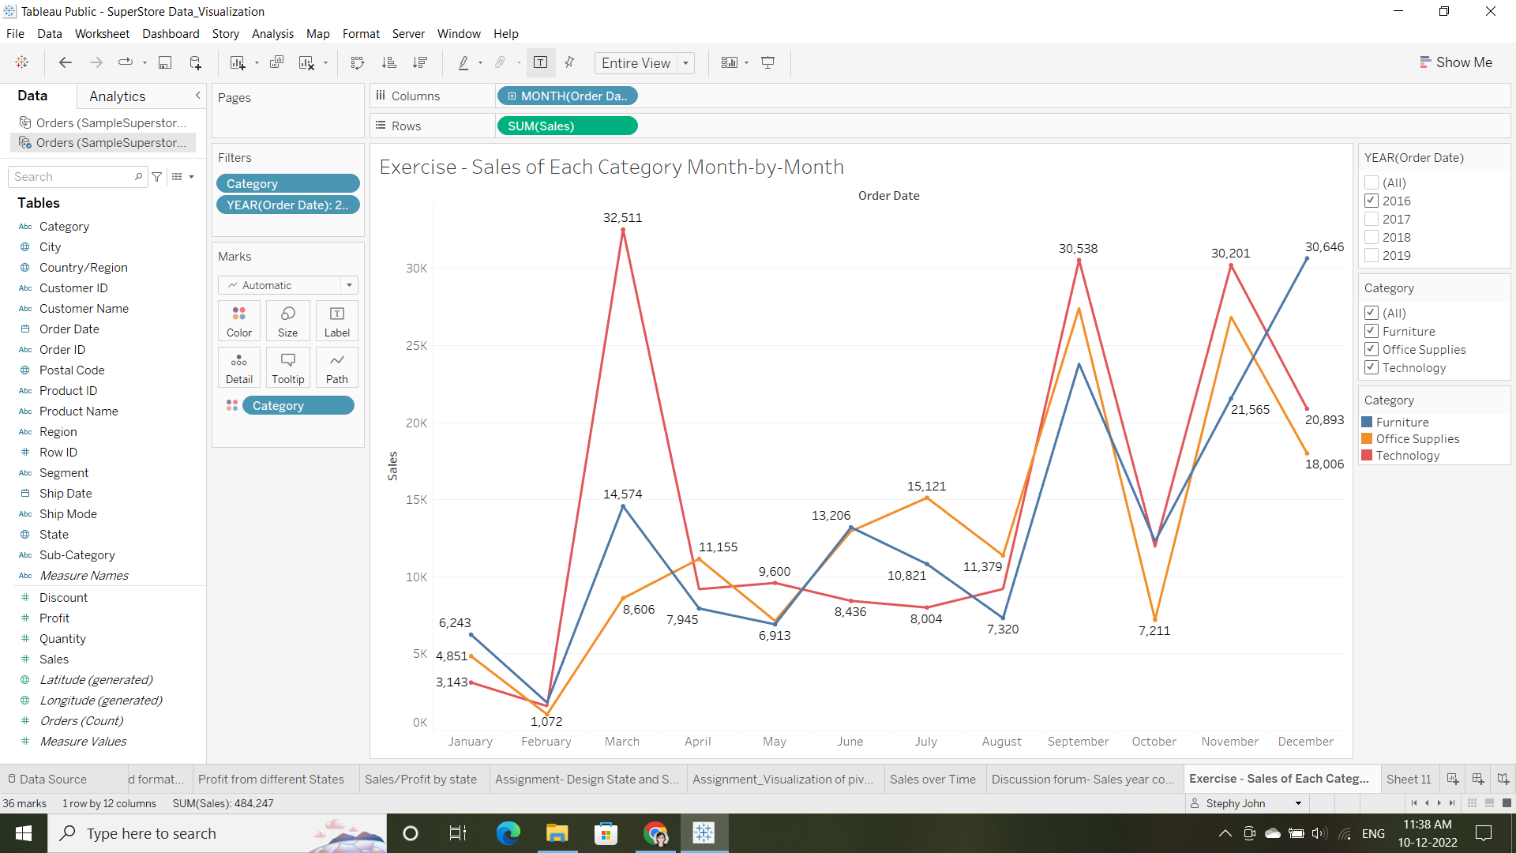

**Year 2016**

* Technology category saw highest sales in the month of March with max sales of 32,511 followed by 30,538 in the month of September and 30,201 in November. Least sales of 1,609 in the month of February.
* Furniture category saw highest sale in the month of December with max sales of 30,646 followed by 23,816 in the month of September. Least sales of 1,840 in the month of February.
* Office Supplies category saw highest sale in the month of September with max sales of 27,423 followed by 26,862 in the month of November. Least sales of 1,072 in the month of February.
* Overall each category had lowest sales in the month of February.

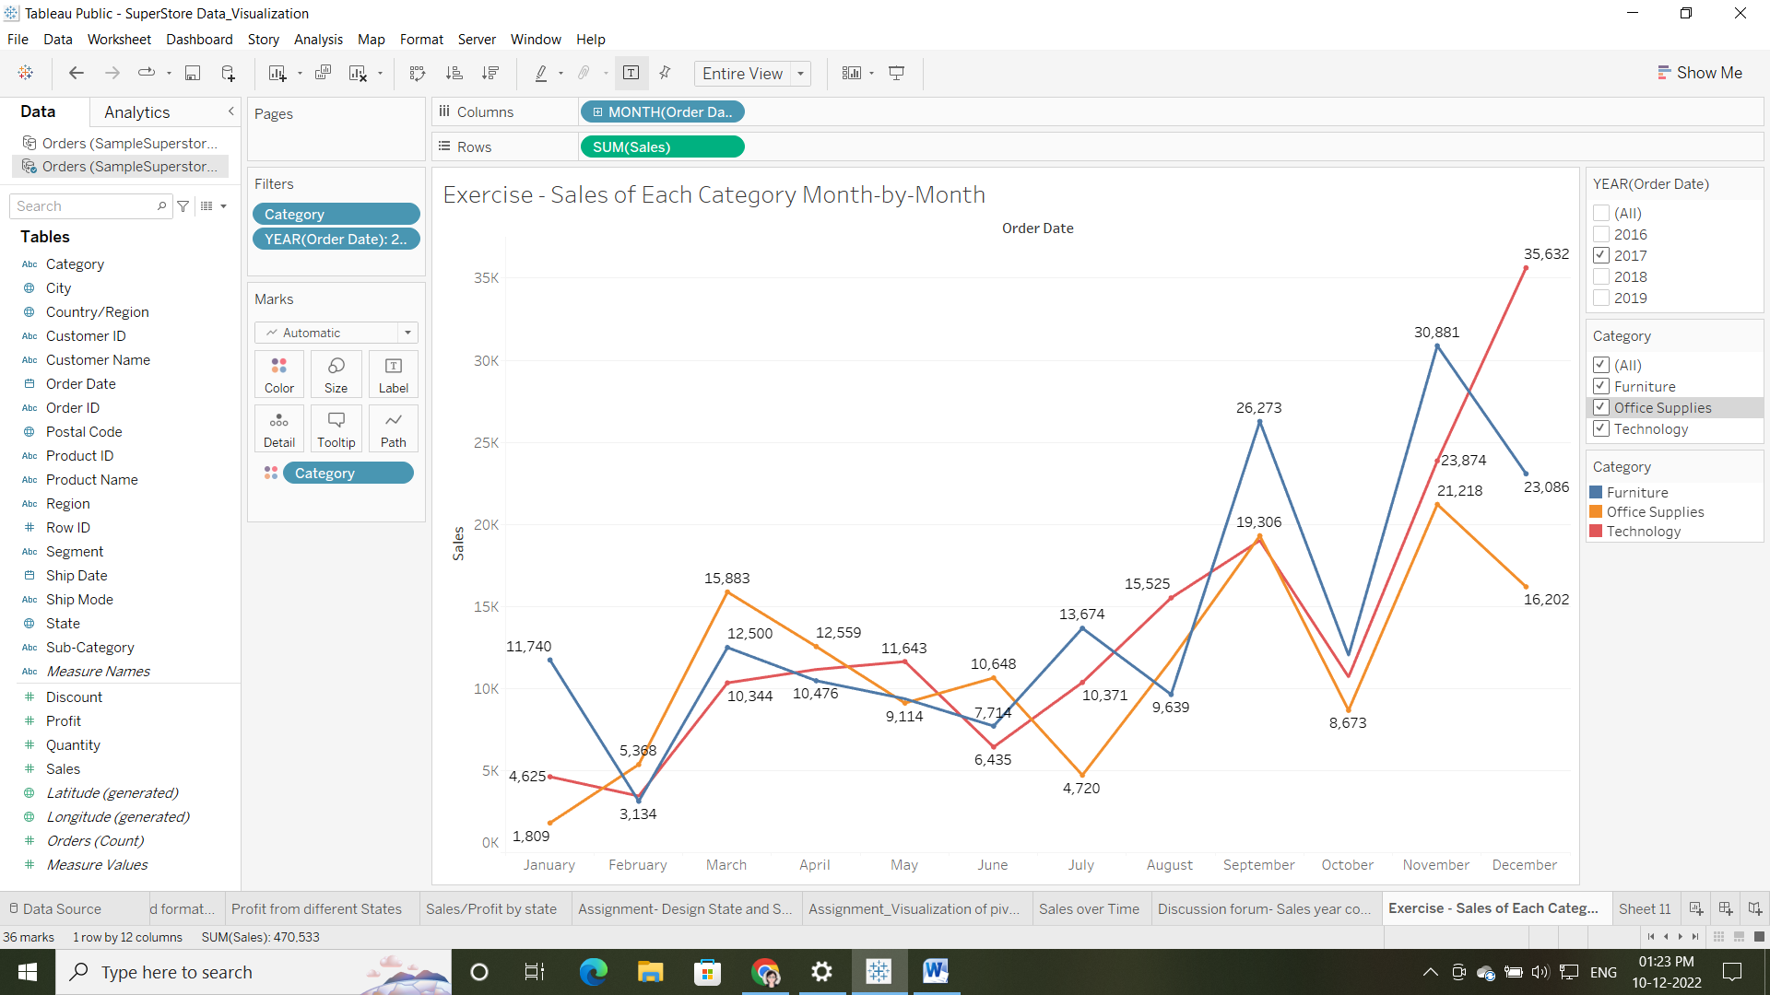

**Year 2017**

* In Technology category there is a dip of 10,344 in the month of March when compared to high sales in previous month. Overall sales were low throughout the year. Highest sales of 35,362 were made in the month of December.
* Furniture category highest sales of 30,881 were made in the month of November followed by September 26,273.But saw a drop of 23,086 in the month of December compared to previous year. Low sales of 3,134 continue in the month of February like previous year.
* Office Supplies category continue highest sales in the month of November and September with max sales of 21,218 and 19,306 which is less compared to year 2016. This year sales are less in the month of January.
* Overall low sales continue in the month of February for technology and furniture category but there is change in sales for office supplies as seen a dip of 1,809 in the month of January.

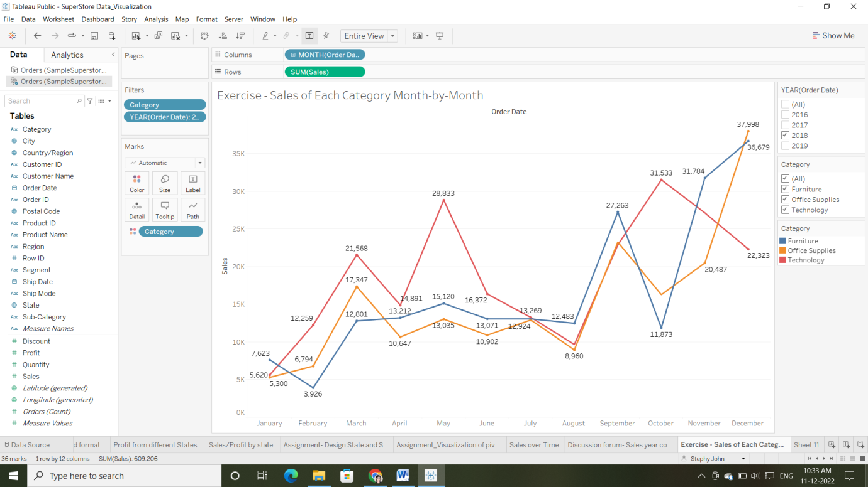

**Year 2018**

* This year Technology category saw highest sales of 31,533 in the month of October but sales dropped in December, November and September compared two previous year’s sales. This time sales 5,620 was lowest in January.
* Furniture category maintains highest sales of 36,679 in December. Again lowest sales of 3,926 in February.
* Office supplies highest sales is 37,998 in December and lowest sales continue in January month.

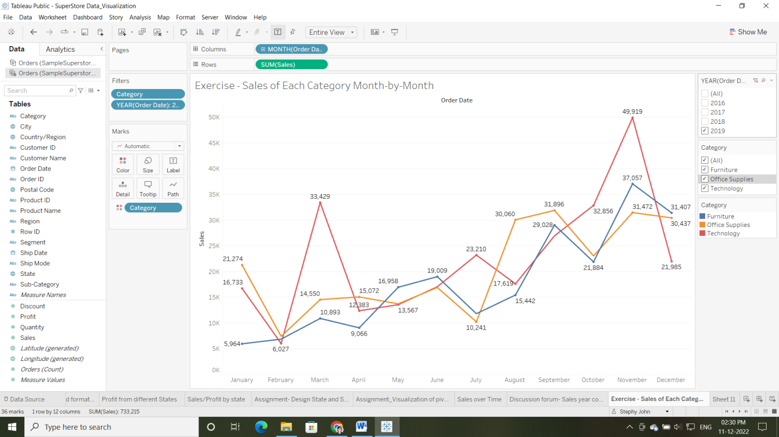

**Year 2019**

* Technology category sales scaled to highest value of 49,919 in the month of December followed by March 33,429. Lowest sales again continue in February month.
* Furniture category maintains highest sales 37,057 in November. Again lowest sales in February.
* Office supplies highest sales of 31,896 in September followed by November and December. This year in January month sales scaled to 21,274 when compared to previous year’s loss. This year February saw lowest sales of 7,408
* Overall each category had lowest sales in the month of February.

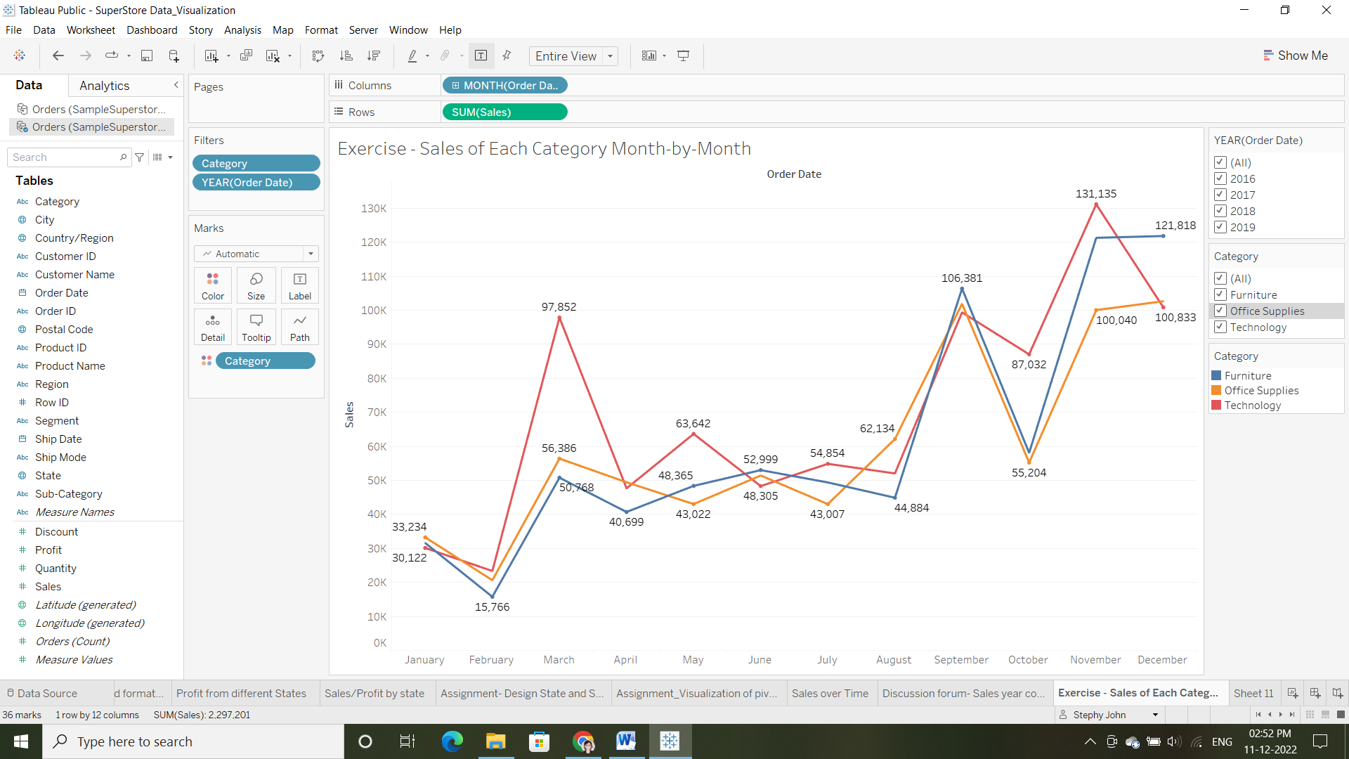

**Conclusion**

* In all four consecutive years, Technology category saw highest sales in November, September and March. And lowest in February.
* In the year 2019, technology and furniture category achieved highest sales in the month of November.
* In the year 2018, Office supplies category achieved highest sales in the month of December.
* In year 2016, technology, furniture and office supplies category achieved lowest sales in the month of February.
* Furniture category saw highest sales in December, November and September. And lowest in February.
* Office supplies category saw highest sales in December, November and September. And lowest in February.
* So it means most of the maximum sales happens for all categories in the month of December and lowest happens in February.